GGN - Geopark Annual Report 2018

1. GEOPARK IDENTITY
- Geopark name, country, regional network:
Taining UNESCO Global Geopark, China; APGN; GGN
- Year of inscription / Year of the last revalidation:2005/2017
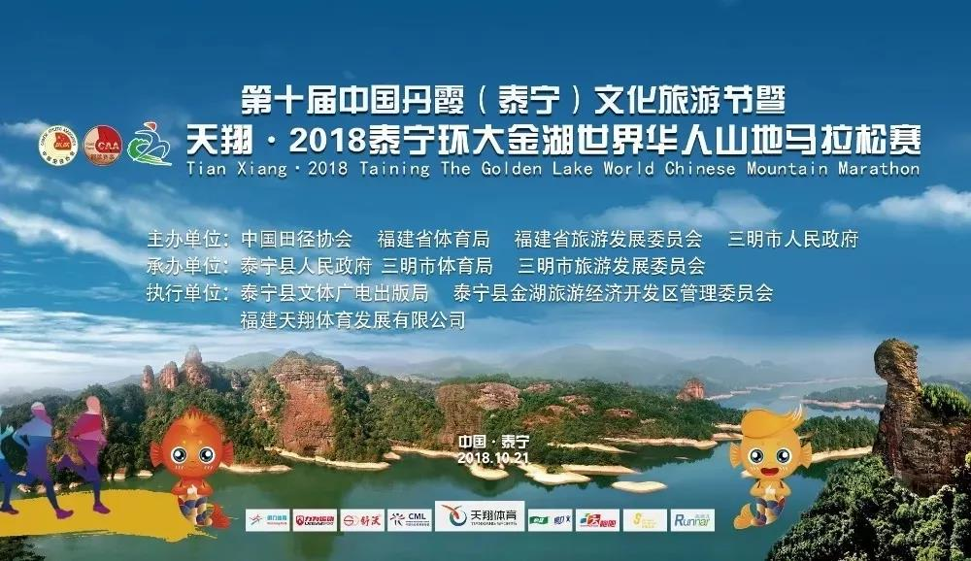
(Representative Photo)
2. GEOPARK FIGURES
- Number of Geopark staffs: 1122 staffs, including 8 geoscientists (5external experts)
- Number of Visitors: 4000, 000+（26,0000+ Geo-tourist）
- Number of Geopark events: 20+
The Geopark has organized a series of large-scale events, such as, a series of activities of "The Land of Meditation in China, The World Heritage of Danxia in Taining, Ecological Beauty of the Homeland, Inheritance of Traditional Culture " were hosted for primary and middle school students, "The town celebrates Spring Festival", "Dajinhu International Tent Festival", "Cycling around Taining Dajinhu Lake", "2018National Open Water Swimming Team Relay Series（The Golden Lake, Taining)", "2018 Taining The Golden Lake World Chinese Mountain Marathon", "The 3rd Carnival of Tourist Guide", "The Line of The Four Seasons in Leisurely Sanming", "2018The First Art Festival of Tourism and Culture in Taining with Meditation of China", "Visit Tourism Exhibition in Europe", etc. These activities have gained good response and expanded the brand influence of the Geopark, bringing over 260,000 tourist trips in the Geopark.
- Number school classes realize Geopark educational programmes:
Organizing all of primary and secondary schools to carry out Learn Travel studies: total of 16 schools / grade 4 , 5 , 7and 8 students / 8679+.
All regional sketch creation demonstration base：/ Cooperate with many national provincial 46 colleges and universities /Sophomore , junior , senior student / 23961+.
- Number of Geopark press release:
1540+ news letters(The WeChat updated once a day, the website 10 days); 3 books ("The Land of Meditation in China", " Taining Young Stage Danxia Landforms"); 2 broadcast-quality HD videos("The Land of Meditation of Taining in China", "Making Wisdom and Dream Fly in the Study Travel"); 20000+ leaflets; 6 educational programme books (boutique lesson plans of Study Travel);

3. GEOPARK ACTIVITIES
- Main achievements in 2018:
GGN has put forward seven suggestions for progress evaluation in 2014-2017 of Taining UNESCO Global Geopark, we made the rectification plan and completed the task of rectification and promotion as required.
- Main contribution of the participation and cooperation networks:
- Paid 2018 annual fee of GGN on time, in accordance with the regulation of IGGP.
- Signed an preliminary agreement with Sobrarbe-Pirineos UNESCO Global Geopark (Spain ) about cooperation matters of sister park.
-Attended the 8th International Conference on UNESCO Global Geoparks (Adamello-Brenta, Italy).
-Attended the conference of China Workshop on Progress Evaluation of UNESCO Global Geoparks (Beijing).
-Attended 2018 Annual Meeting on China's UNESCO Global Geoparks.
-Established friendly cooperative relations with Liege province (Belgium). Beyond that, staffs of Taining UNESCO Global Geopark Administrative Committee made exchange visits and promotion of the Geopark forwardly on Germany, Spain, Belgium etc.
- Management and Financial status:
Taining County Party Committee and County Government attaches great importance to the construction and protection of Taining UNESCO Global Geopark. The Administration Committee of Taining UNESCO Global Geopark has been established by law, which is in charge of the Geopark planning, development, protection, utilization and construction under this unified management system.
The Geopark follows the principle of "balance budget with small surplus" to strictly implement the Geopark development and planning, to improve protection, management and construction investment. In general, the Geopark has achieved a stable financial status.
- Geosites protection:
-According to the "Master Plan of Taining Global Geopark, compiled 13th Five-Year Plan for Tourism Development of Taining Geoapark, "Master Plan of Jinhu Lake Ecological Demonstration", "Taining Geopark Intelligent Tourism Plan". The Geopark has improved local laws and regulations, and standardized Geopark management.
-Exploring the "1+N" joint management model, improving the Geopark protection management network.
-The Geoheritage database has been established for the Geopark and the means of information management system of the Geopark has been improving.
-The Geopark has invested 42 million Yuan and completed a series of Geopark infrastructure constructions, geoheritage protection and environmental improvement projects in 2018.
- Sustainable tourism(Geotourism):
In 2018, tourists visited the Geopark has reached over 4 million people. The number of visitors and the average annual income increasing ratio is above 10%. The income from the Third Industry of the Geopark, which mainly consisting of tourism industries, account for 1/3 of County’s GDP. Tourism income accounts for 1/4 of the farmers’ net income. The tourism participators account for 1/5 of the county's total labor force.
- Education programme is expanded with new audiences:
local people and visitors.
- New Education programmes on geoconservation, sustainable development and disaster risk reduction :
The Geopark takes Danxia landform geoheritage as market selling point, making every effort to improve Geopark visibility, highlighting the scientific value of young stage Danxia landform, themed "China Danxia, Spectacular Taining", which is also the unified marketing and promotion image for all scenic spots in the Geopark. Each scenic spots of the Geopark has a promotion slogan based on this theme.
The Geopark has newly increased 40+ interpretation panels at geoheritage sites, 2 free WIFI coverage, and made revision on the layout and contents of the preexisting 106 interpretation panels. After the improvement, the interpretation system for the geoheritages has more scientific contents and more easy to understand.
- Strategic Partnership :
Having Strategic Partnership with 12 UGG, 3 National Geoparks, 120+other Organization (Travel Agency, Transportation Companies, Hotels, Restaurents, schools, Universities…)
- Promotion activities:
The Geopark have been using internet, QQ, and Wechat official account to post message, expanding channels for various kind of visitors to gain information of the Geopark. In addition, the Geopark advertised in service areas along Beijing-Fuzhou Highway and bullet trains that come to Fujian. In addition, a series of recommendation and introduction activities, such as, "the introduction of Taining UNESCO Global Geopark in the feature programme of Introduction of China by the county magistrate of Taining", "the introduction of Taining by the short video of One Minute of Fujian in WeChat official account of the People's Daily, " A television interview of Chinese photographic Chronicles on the science and educational channel of CCTV with Taining", "a propaganda film of The Land of Meditation of Taining was played in 2018 China World Heritage Tourism Promotion Alliance (Tibet) Conference". All of the above show natural and cultural landscapes of the Geopark. Moreover, the Geopark dispatched 13 staffs to promote 5 new exquisite tourism routes, organized 60 times travel agency to visit, carried out 30 a target market promotion activities, so as to consolidate and expand tourist source market, making the Geopark maintain growth in tourism.

4. Contacts:
Manager:
Jiang Dongbin, Director（TNJHGWH@126.com）
TEL：001—86—598—7833821; TAX:001—86—598—7833243
http://taininggeopark.com/（ Chinese/English bilingual）
http://t.qq.com/tainingly（Chinese/ Part of English）
Geologist:
Chen Ningzhang Director of Geo-protection Bureau (FJCNZ@163.com)
Lai Longfu Senior Engineer (383619002@qq.com)
Ren Fang Ph.D (546615019@qq.com)

